Mark Pucci Media
FOR IMMEDIATE RELEASE
January 4, 2024
Contact: Mark Pucci (770) 804-9555 / mark@markpuccimedia.com
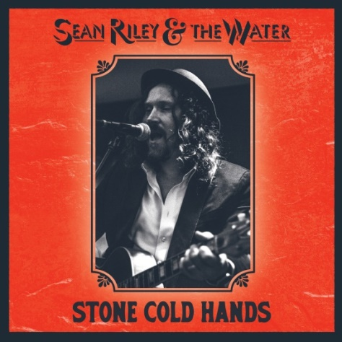
New Orleans Roots Music Wizard Sean Riley Brings Life to New Stone Cold Hands Album Out March 8th from Pugnacious Records

NEW ORLEANS, LA – Pugnacious Records announces a March 8th release date for Stone Cold Hands, the new album from singer/songwriter/guitarist Sean Riley. Based in New Orleans, Riley is a familiar face in the New Orleans music world, playing frequently throughout the city, from the Bywater to the French Quarter and Uptown, as well as regional shows in Louisiana, Mississippi, and Alabama. Riley also tours extensively in Europe and Australia. Sean Riley plays solo and with his backing band The Water, aptly named for the fluidity of different musicians joining him on stage.

Stone Cold Hands is the first full length offering from Sean Riley & The Water, following the Biting Through EP released under his original moniker, Old Riley & The Water. (“Riley hooks his listener with varied guitar riffs that are part of his signature.”- Dan Willging, OffBeat Magazine).

Stone Cold Hands features nine original songs by Sean Riley, all showcasing his distinctive voice, lyrics, guitar style, and arrangements. The lone cover is Jimmy Reed’s “High and Lonesome,” a swaggering Mississippi juke blues tune.

“This record is my musical tribute to New Orleans, and Southern folk traditions,” says Riley. “It's a celebration of the highs of dance-filled evenings, communal feasts, and all-night parties - to the lows of facing grief, fear, and the loss of what we hold dear. The songs represent the ebb and flow of emotions, from high-energy house party rockers to tear-in-my-beer barroom reflections and down-on-your-luck country blues, back to the uplifting spirit of self-worth and love.”

Stone Cold Hands features some of Louisiana’s most-lauded musicians. Multi-instrumentalist and practitioner of Zydeco and Afro-Louisiana music Bruce “Sunpie” Barnes plays accordion and harmonica on four tracks: “Dance Me One More Time,” “Truck Route Blues,” “Out All Night” and “Jump the Line.” Cajun/Zydeco musician and “Louisiana’s Rockin’ Fiddler” Waylon Thibodeaux shines on "Rosie’s Rag” and “A Losing Hand.” Phil Breen shows his versatility and strength on keys and organ for the title track, “Stone Cold Hands,” as well as “Go Easy on Me,” “A Losing Hand,” “Rosie’s Rag” and “Shine a Little Stronger.” Tiffany Pollack graces the album with sweet harmonies on “Stone Cold Hands” and “Go Easy on Me.” She is joined by Megan Harris Brunious and Whitney Alouisious to create a tingling three part harmony to the album bookends, “Dance Me One More Time” and “Shine a Little Stronger.” Last but certainly not least is the record’s thumping rhythm section, consisting of New Orleans’ own limitless drummer Mike Barras, and acting as both bassist and producer, the unwavering Dean Zucchero.

“Recording this album was the most fun I've ever had in a studio,” adds Riley. “Every day was filled with enthusiasm and positivity - no off days whatsoever! The album was recorded at Rhythm Shack Studio in New Orleans. We worked together as a team, trying to hit the right note each time, and I believe that energy resonates in the final product. Dean Zucchero (producer) along with Jake Eckert (engineer) masterfully captured the sound, achieving a big budget sound on a working musician's budget. It was such a collaborative effort, and everyone involved generously contributed their time. It truly speaks to the spirit of the New Orleans music community.

“Some of these songs were written or took shape during the pandemic. In the midst of all that craziness, writing and composing became a way to ease my worried mind. What ultimately came of it is a collection of songs that reflect my belief in the inherent goodness in people, and a deep embrace of the love I feel for the cherished people in my life, particularly because while creating this record I experienced the loss of some profoundly significant individuals. Long story short, this music helped breathe life into me, providing me both solace and energy.”

Sean Riley sums it up by saying: “This album is made to be cranked up - whether you're on a back porch, on a fire escape, on your daily commute, dancing in your kitchen making dinner, on your morning run, or on your couch in fat, warm socks. The intention is to bring some joy and that good feeling in your bones. Play it loud!”

Hi-res cover: http://www.markpuccimedia.com/Sean-Riley-Hi-Res-Cover.jpg
Hires photo: http://www.markpuccimedia.com/Sean-Riley-Hi-Res-by-Bridgette-Charbonneau.jpg

www.seanrileyandthewater.com www.pugnaciousrecords.com

-30-

